CLOUD COMPUTING LAB: WEEK 9

PES1201802127

Siddharth K Rao

**TASK 1: Plan and Configure an Amazon EMR Cluster**

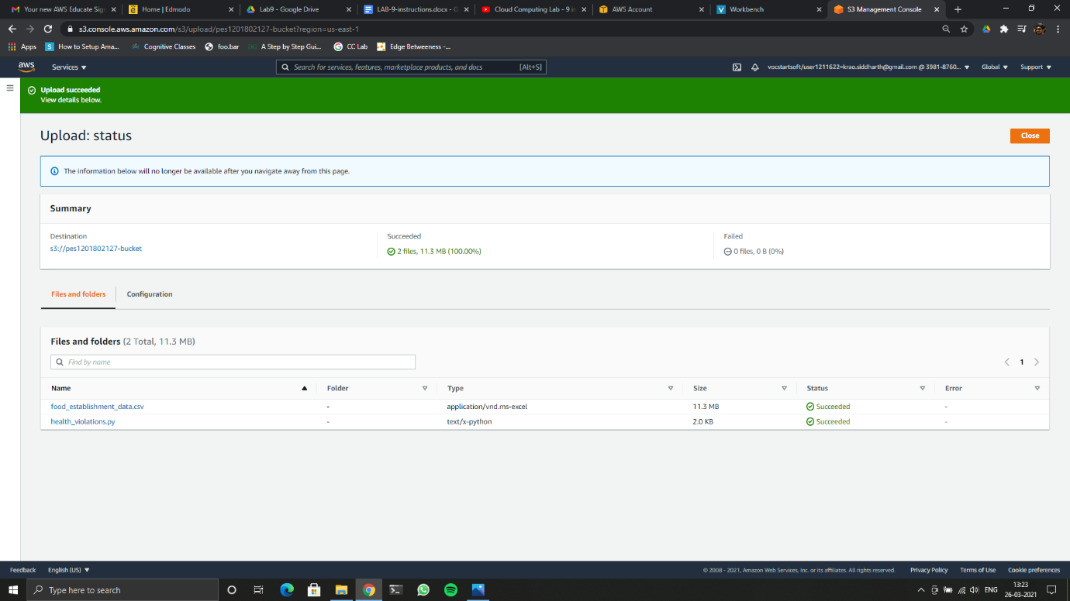

9a

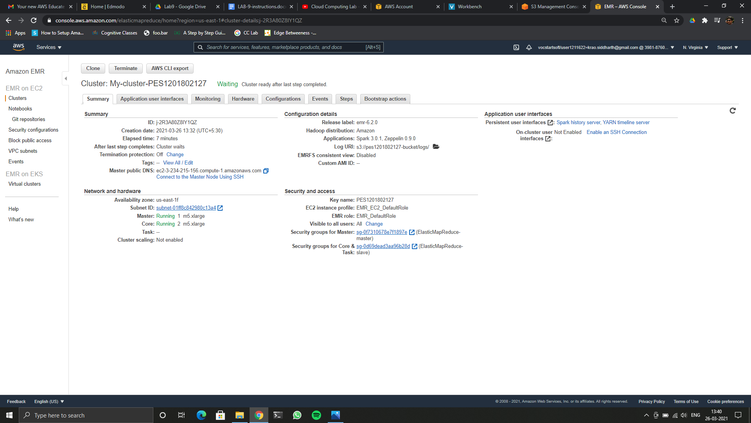

9b

**TASK2: Managing Amazon EMR Clusters**

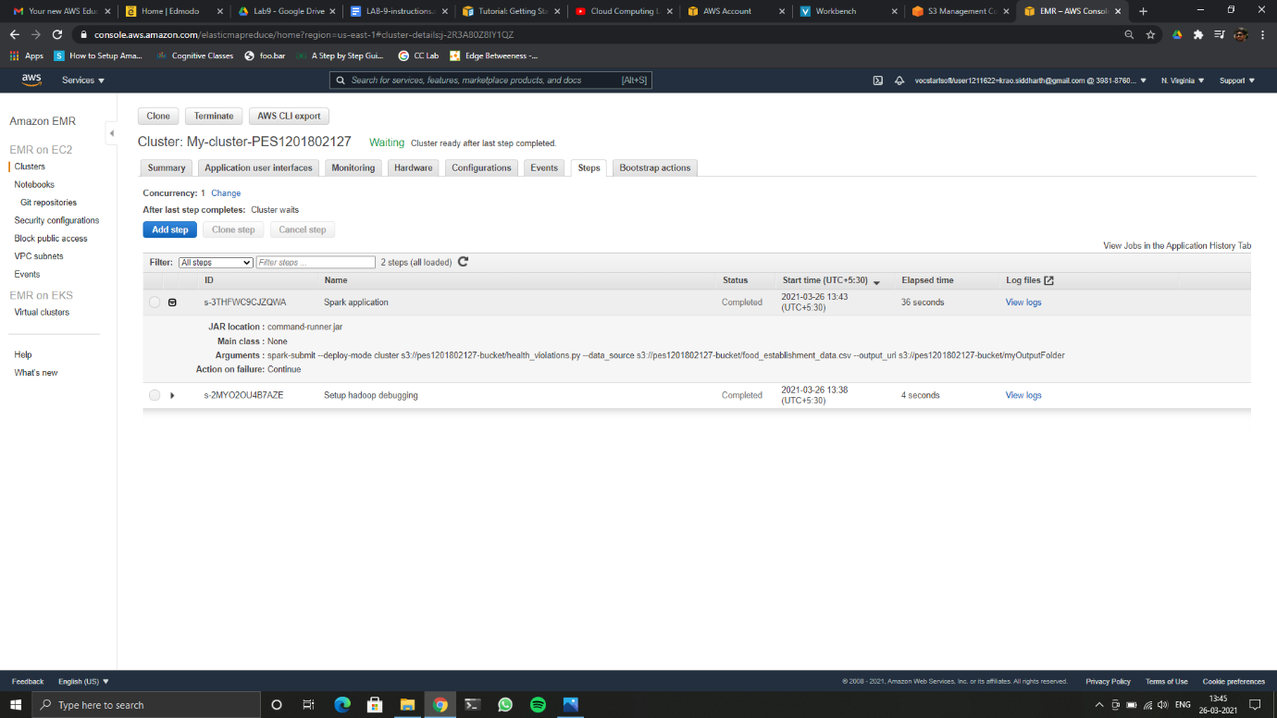

9c

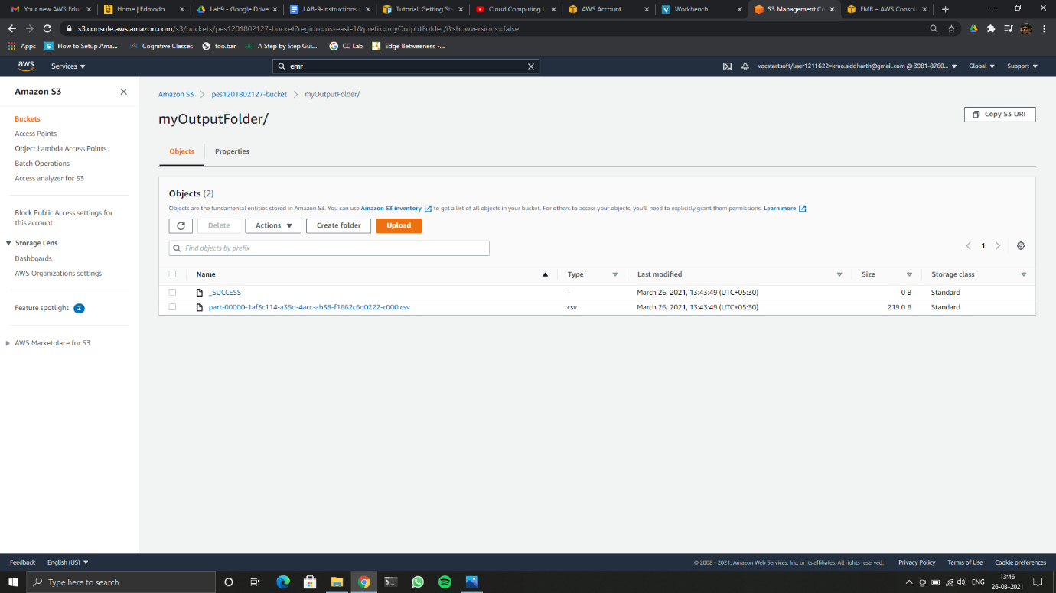

9d